Wo: PNS
Wann: 12.09.2013;
Self-organization on Small Scales:
Fabrication beyond the Top-down and Bottom-up
Prof. Ashutosh Sharma
Centre of Nanosciences
Department of Chemical Engineering
Indian Institute of Technology
Kanpur, INDIA
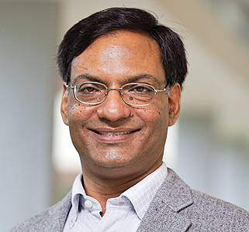
Inexpensive, fast and large-area nanofabrication across a variety of materials remains a challenge which impacts important advances in energy, electronics, health and environment.
This talk will summarize some of our work on micro/nano fabrication based the self-assembly and self-organization in soft materials based on control of instabilities in small scale systems. I will illustrate the basic principles by examples from Directed Dewetting of thin (5 nm-100 nm) polymer liquid films, Elastic Contact Instability of soft solid films, Electric Field Modulation of Interfaces, Directed Electrospinning and Diffraction patterned Induced Self-organization.

Representative References:
From finite-amplitude equilibrium structures to dewetting in thin polymer films on chemically patterned substrates, Soft Matter 8, 10394 (2012);
Creating self-organized sub-micron contact instability patterns in soft elastic bilayers with a topographically patterned stamp, ACS Applied Materials & Interfaces 4, 355 (2012);
Improved graphitization and electrical conductivity of suspended carbon nanofibers derived from carbon nanotube/polyacrylonitrile composites by directed electrospinning, Carbon 50, 1753 (2012);
Self-organized nano-lens arrays by intensified dewetting of electron beam modified polymer thin-films, Soft Matter 7, 11119 (2011);
Multiscale pattern generation in viscoelastic polymer films by spatio-temporal modulation of electric field and control of rheology, Advanced Functional Materials 21, 324 (2011);
Ultrafast large area micropattern generation in non-absorbing polymer thin-films by pulsed laser diffraction, Small 7, 758 (2011);
Fabrication and conductivity measurement of suspended carbon nanofiber arrays, Carbon 49, 1727 (2011).

Acknowledgments
Collaborations with Alamgir Karim (U. Akron), G. U. Kulkarni (JNCASR), Marc Madou (UCI) and Rabibrata Mukherjee (IITKgp) in the above studies are gratefully acknowledged.

